 | ASSIGNMENT – 2
 | Python Programming
Assignment Date |  | 24-09-2022
Student Name |  | Mr.NITHISH KUMAR
Student Roll Number |  | 911519106006
Maximum Marks |  | 2 Mark

Question-1 :

1 . Importing Required Package

Solution :

import pandas as pd
import seaborn as sns
import numpy as np
from matplotlib import pyplot as plt
%matplotlib inline

Question-2 :

- Loading the Dataset Solution :

df = pd.read_csv("/content/Churn_Modelling.csv")

df

Output:
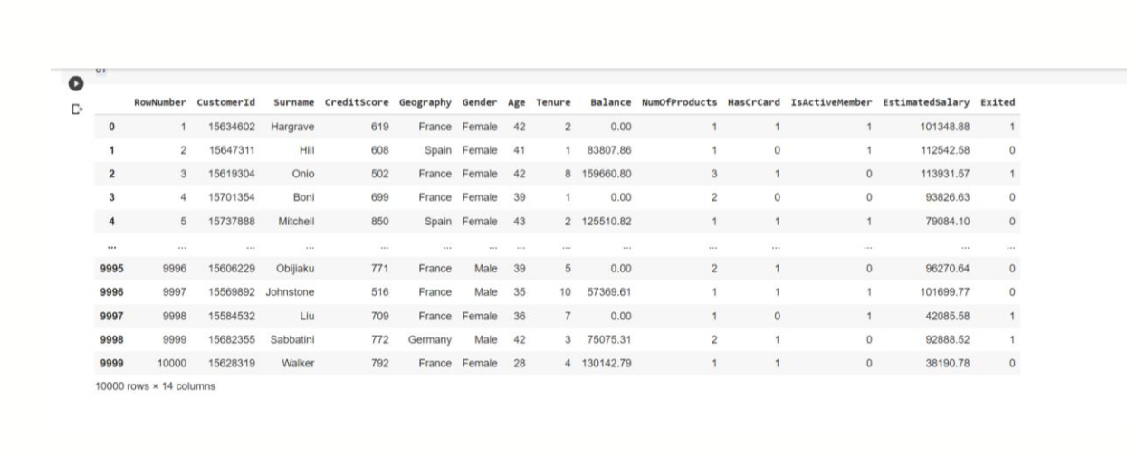

3. Visualizations

Question-3 :

3.1 Univariate Analysis

Solution:

sns.displot(df.Tenure)

Output:
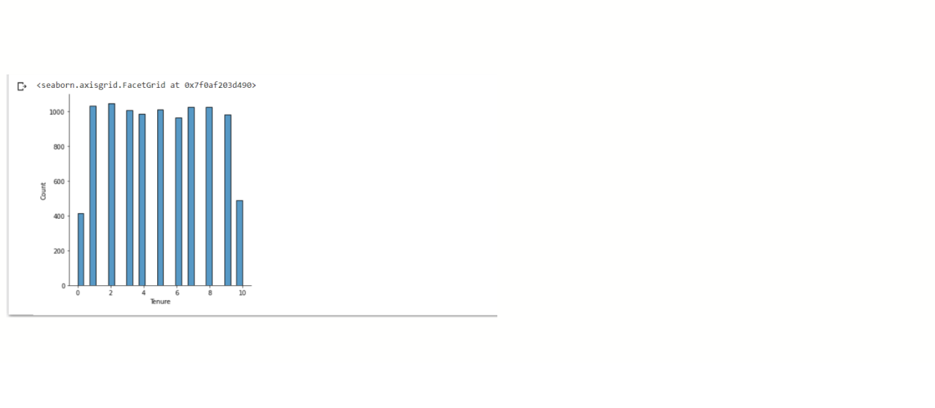

3.2 Bi-Variate Analysis

Solution:

df.plot.line()

Output:
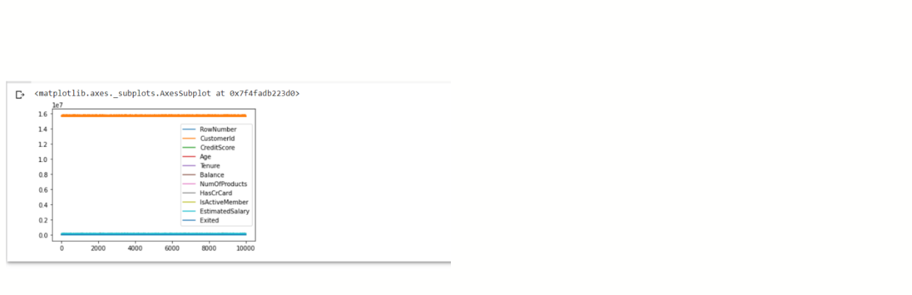

3.3 Multi - Variate Analysis

Solution:

sns.lmplot("Age","NumOfProducts",df,hue="NumOfProducts", fit_reg=False);

Output:
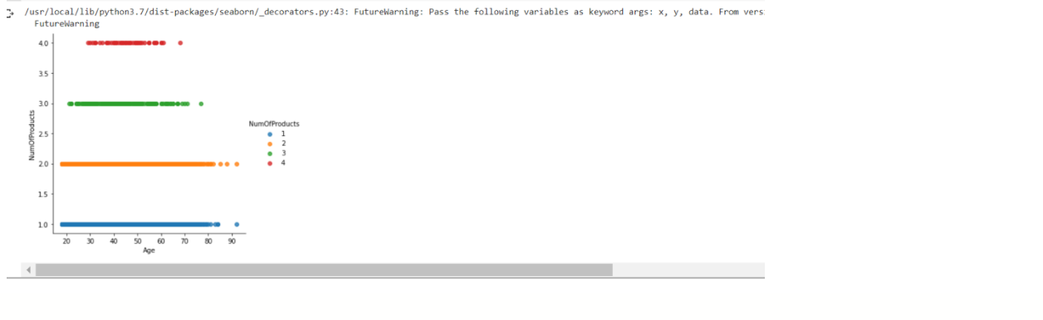

4. Perform descriptive statistics on the dataset.

Question-4 :

Solution:

df.describe()

Output:
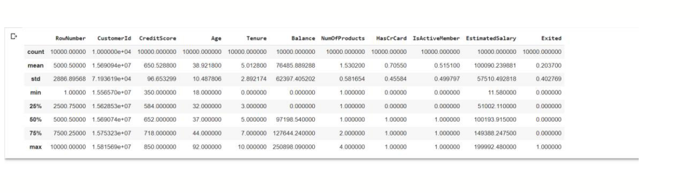

5. Handle the Missing values.

Question-5 :
Solution:

data = pd.read_csv("Churn_Modelling.csv")
pd.isnull(data["Gender"])

Output:
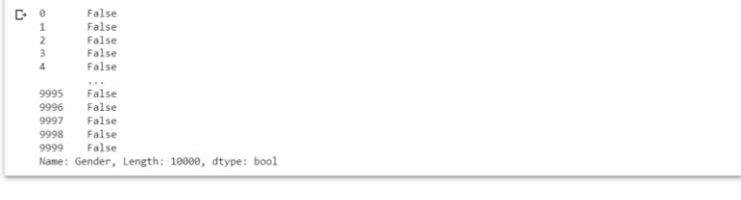

Question-6:

- Find the outliers and replace the outliers. Solution:

df["Tenure"] = np.where(df["Tenure"] >10, np.median,df["Tenure"]) df["Tenure"]

Output:
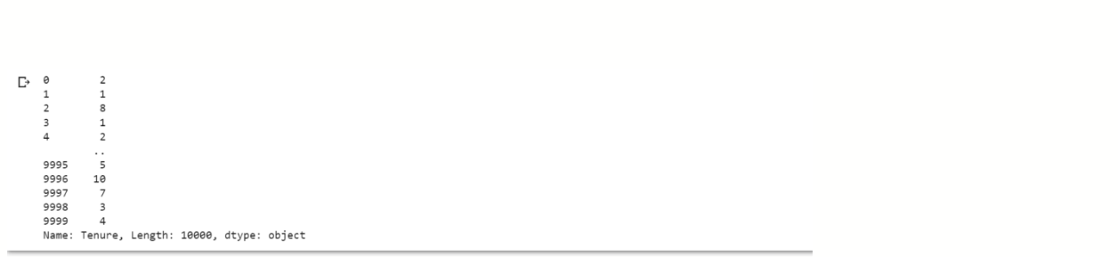

Question-7 :

- Check for Categorical columns and perform encoding. Solution:

pd.get_dummies(df, columns=["Gender", "Age"], prefix=["Age", "Gender"] ).head()

Output:
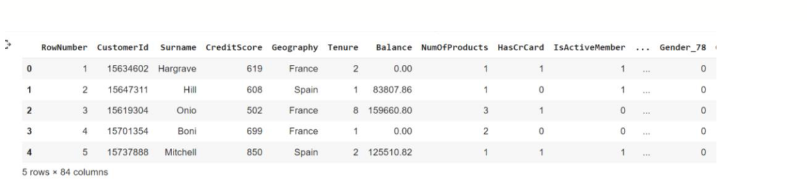

Output:
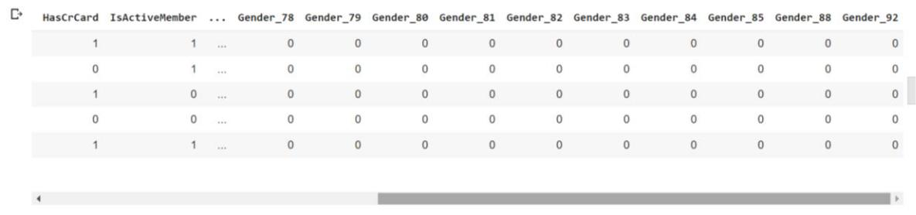

Question-8:

- Split the data into dependent and independent variables 8.1 Split the data into Independent variables.

Solution:

- = df.iloc[:, :-2].values print(X)

Output:
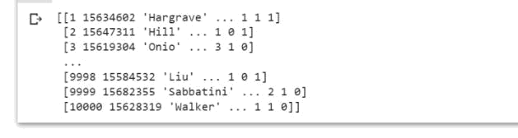

8.2 Split the data into Dependent variables.

Solution:

Y = df.iloc[:, -1].values
print(Y)

Output:
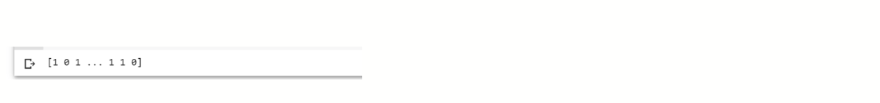

Question-9 :

- Scale the independent variables Solution:

import pandas as pd

from sklearn.preprocessing import MinMaxScaler scaler = MinMaxScaler()
df[["RowNumber"]] = scaler.fit_transform(df[["RowNumber"]])
print(df)

Output:
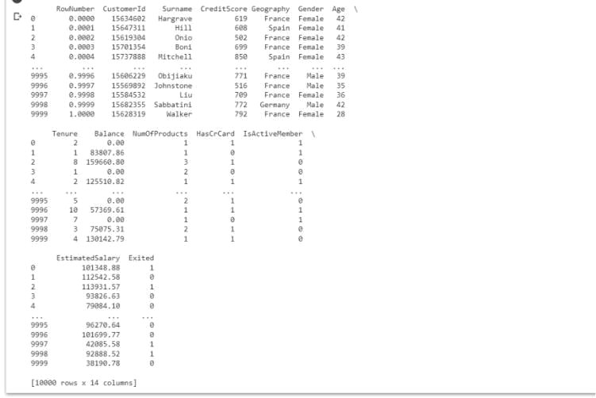

Question-10 :

- Split the data into training and testing Solution:

from sklearn.model_selection import train_test_split train_size=0.8

- = df.drop(columns = ['Tenure']).copy() y = df['Tenure']

X_train, X_rem, y_train, y_rem = train_test_split(X,y, train_size=0.8) test_size = 0.5

X_valid, X_test, y_valid, y_test = train_test_split(X_rem,y_rem, test_size=0. 5)

print(X_train.shape), print(y_train.shape) print(X_valid.shape), print(y_valid.shape) print(X_test.shape), print(y_test.shape)

Output:
